Day-2 programs outputs p

PROGRAM-1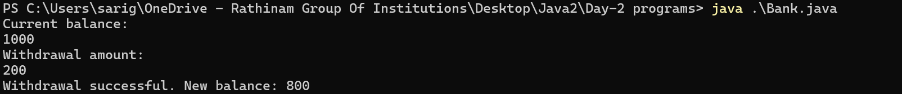

PROGRAM-2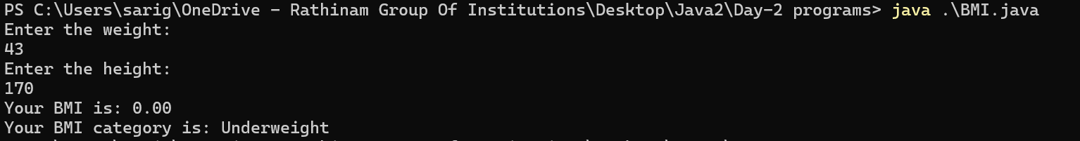

PROGRAM-3



PROGRAM-4

PROGRAM-5

PROGRAM-6

PROGRAM-7



PROGRAM-8



PROGRAM-9

PROGRAM-10